Official Adoption Agreement

For the Direct Support of:

All Saints Lutheran Church
Arlington, Texas

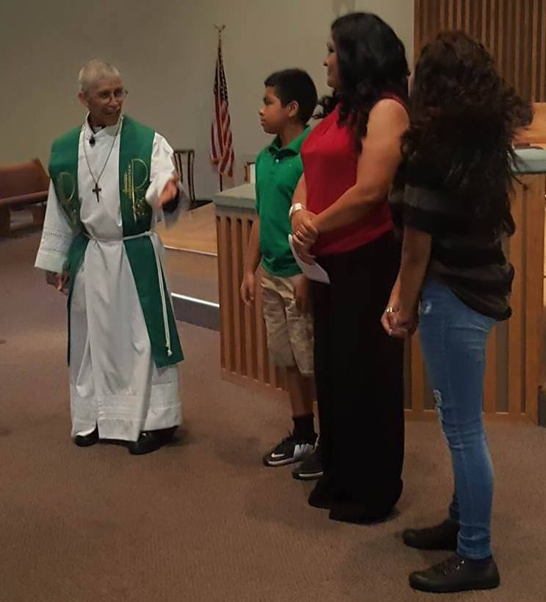
A Spanish language mission began on the campus of All Saints Lutheran Church in May, holding services of Word and Sacrament in Spanish on Sunday afternoons. After a kick-off celebration in which two area Hispanic NALC congregations joined us, weekly services began. Outreach to the local community, membership classes, and Bible study have led to the growth of this mission. The mission of the Church is to go into all the world, making disciples of all nations, baptizing them in the name of the Father, and the Son, and the Holy Spirit; and teaching them everything that Jesus has commanded. All Saints Lutheran Church exists to fulfill this mission, and is located in the greater Dallas-Fort Worth metropolitan area, in which many people speak Spanish as a first language. All Saints has the organizational infrastructure and physical space to support a Spanish-language ministry, and is conveniently located near two freeways, allowing a Spanish language ministry to draw people from around the region as well as the local neighborhood. Additionally, All Saints offers First Communion, Confirmation, and youth ministry in English, creating an ideal circumstance for first and second-generation families who attend worship in Spanish, yet require student ministry conducted in English for their second and third generation children.
For more information, please contact Pastor John Scheusner at: john.scheusner@allsaintsarlington.org or Enmanuel Torres at: etorres1286@gmail.com.

Amount of support Pledged from our Family or Organization: $_________________
Our Gift will be sent: ( ) Once with this agreement ( ) At the end of one year
( )Semi-Annually ( ) Quarterly ( ) Monthly

_____________________________________________________
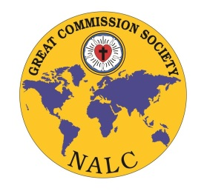
Congregation or Individual’s Name

_____________________________________________________
Address/ City/State/Zip

_____________________________________________________
Email Address

_____________________________________________________
Signature and Date

Great Commission Society of the NALC
Instructions for Official Adoption Agreement:

□ Please print three copies of this agreement and retain the first for your records

□ Please send the second copy and funds to:
All Saints Lutheran Church
4325 SW Green Oaks Blvd
Arlington, TX 76017

Please note “Spanish Speaking Ministry” in the memo line of the check.

□ Please send the third copy to:
North American Lutheran Church
Missions Office
3500 Mill Run Dr.
Hilliard, OH 43026

Should you have any questions, please contact Jenny Brockman in the Missions Office at: 614.777.5709 or jbrockman@thenalc.org

