Official Adoption Agreement

For the Direct Support of:

Bed Brigade- St. John’s Evangelical Lutheran Church
Grove City, Ohio

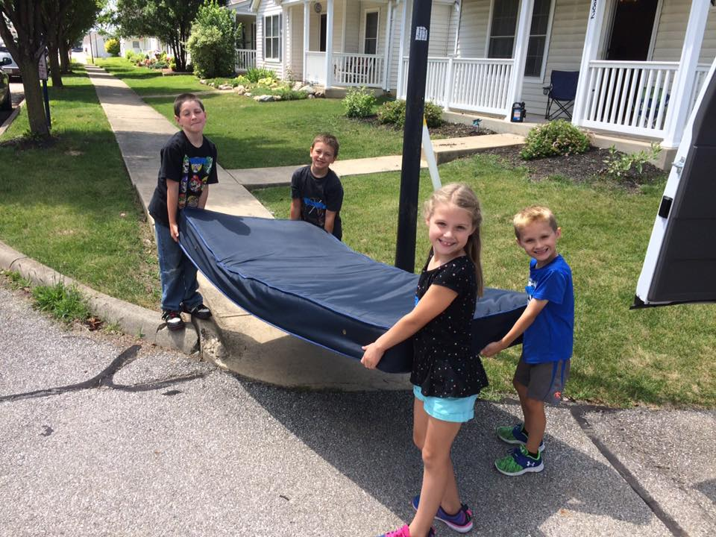
Bed Brigade Grove City is a service ministry partnering with St. John’s Evangelical Lutheran Church to provide much needed beds and the hope of Jesus to the Columbus, Ohio area. In 2017, the Bed Brigade visited over 200 homes and families, giving away 560 beds, as well as distributing 560 Bibles and Bible storybooks to recipients of the beds. Please join us in prayer that the adults and children are impacted to the point where there are choices made for love instead of violence or abuse; that some choose to reach out to Jesus instead of drugs; and that hope can grow in many hearts leading them out of the cycle of poverty. For more information, please contact Jeff Stenerson at: StenersonJ@Grangeinsurance.com or visit: www.stjohnsgc.org.

Amount of support Pledged from our Family or Organization: $_________________
Our Gift will be sent: ( ) Once with this agreement ( ) At the end of one year
( )Semi-Annually ( ) Quarterly ( ) Monthly

_____________________________________________________
Congregation or Individual’s Name

_____________________________________________________
Address/ City/State/Zip

_____________________________________________________
Email Address

_____________________________________________________
Signature and Date

Great Commission Society of the NALC
Instructions for Official Adoption Agreement:

□ Please print three copies of this agreement and retain the first for your records

□ Please send the second copy and funds to:
Bed Brigade
c/o St. John’s Evangelical Lutheran Church
3220 Columbus Street
Grove City, Ohio 43123

□ Please send the third copy to:
North American Lutheran Church
Missions Office
3500 Mill Run Dr.
Hilliard, OH 43026

Should you have any questions, please contact Jenny Brockman in the Missions Office at: 614.777.5709 or jbrockman@thenalc.org

